# BBC Remarc App – Administration Guide

## Administration

### Introduction

The application stores 3 primary types of content – Audio, Video and Images. These content types define “resources” which can be viewed using the main application, searchable via associated metadata.

A single resource will be associated multiple pieces of content, tied together by an identifier – the filename (minus the extension). For example, consider a resource that plays audio recorded from an orchestra. It may contain the following content:

* Orchestra.jpg   
  (image used to represent the audio file, used as a background image & a thumbnail)
* Orchestra.mp3  
  (the audio in an MP3 format)
* Orchestra.ogg

(the audio in an OGG format)

The above 3 pieces of content will be associated to one single resource with the identifier “Orchestra”.

All resources can have an associated image used for display in the carousel and the thumbnail. If the image is not present, a default image will be displayed. If no other type of content is associated to this resource, the resource will be labelled as being of type “Image”. However, if an audio file is also associated to the resource, it will instead be labelled as being of type “Audio”.

When associating audio and video files to resources, it is recommended that multiple formats of the same content is provided in order to support all browsers. The file formats supported are given below:

|  |  |
| --- | --- |
| Resource Type | File Formats |
| Image | *.jpg |
| Audio | *.mp3, *.ogg |
| Video | *.mp4, *.ogv |

A resource must be associated with two metadata tags before it can be searchable from within the system; “Theme” and “Decade”. These are free-text, but should match the text given in the home screen of application (e.g “Sport” and “1950s”).

### Bulk Upload

The system supports a bulk upload in order to import resources into the application. This is accessible from the Admin page home page by clicking “Upload Resources”.

The bulk upload takes a single zipped archive (.zip) and should adhere to the guidelines given below.

* The archive can contain any number of subfolders. A folder may be empty, or simply a parent folder (with only sub folders contained within)
* For a folder to be processed, it should contain a .properties file (see below) – otherwise all content within that folder will be ignored (excluding sub folders)
* All content within the folder will be processed, but only files that much the supported file extensions given above will be evaluated
* Resources will be created based upon files with the same filename, minus the extension, as indicated above. Care should be taken to ensure the filenames are identical in order to ensure the files are correctly associated together.
* Content will not be associated together if they have the same filename but exist in different folders. All resources are constructed only from the content that exists in the same folder.
* Resources will the same identifier will result in unexpected behaviour. This can occur if you have a resource in the system already with the id “Orchestra”, then perform a bulk upload with more content, which also contains files with the name “Orchestra”.

### Properties File

The properties file required for the bulk upload can be created using Notepad. It is simple a text file, which the file extension changed from “.txt” to “.properties”.

The contents takes key-value pairs as the example gives below:

*theme=Family  
decade=1940s*

Each properties file must contain an entry for both “theme” and “decade”

All content within the same folder as the properties file will inherit the same metadata. For example, having 20 images in the same folder as the above properties file, will result in all 20 resources associated to those images having a “theme” set to “Family” and a “decade” set to “1940s”.

#### Example Structure

Following the above guidelines allows the user to easily group content together within an archive. An example file structure is given below. This is for reference only to demonstrate one possible approach.

* Archive Root
  + Folder: Sport
    - Folder: 1940s
      * .properties (“theme=Sport” & “decade=1940s”)
      * Images, Videos and Audio
    - Folder: 1950s
      * .properties (“theme=Sport” & “decade=1950s”)
      * Images, Videos and Audio
  + Folder: Events
    - Folder: 1940s
      * .properties (“theme=Events” & “decade=1940s”)
      * Images, Videos and Audio
    - Folder:1950s
      * .properties (“theme=Events” & “decade=1950s”)
      * Images, Videos and Audio
  + Folder: Work
    - Folder: 1980s
      * .properties (“theme=Work” & “decade=1980s”)
      * Images, Videos and Audio

### Managing Uploaded Resources

From the Admin home page, selecting the “Manage Resources” will allow you to browse any resources that have been uploaded to the application.

The file tree shows a view of all the content stored on the server, grouped by its resource type.

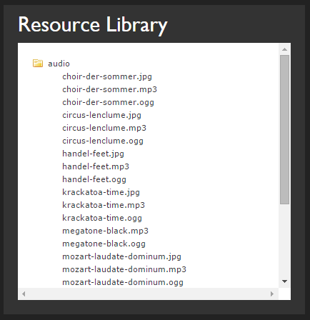

Here, the resource has the id “circus-lenclume” and has 3 pieces of content associated to it (1 image file, 2 audio files).

Selecting any file will bring up the Resource Preview for its associated resource. In the example above, selecting “circus-lenclume.ogg” will display the information for the Resource with the id “circus-lenclume”.

The preview panel shows an indication of how that resource will be rendered in the application, including its associated background/thumbnail image if applicable.

From here, the resource can be deleted using the “Delete” button – this will remove the entire resource from the application, including all associated content.

The metadata for the resource can also be updated using the text box and pressing the “Save” button. Only values for “Theme” and “Decade” will be saved against the resource. Please note, the values for these fields are case sensitive. There is no validation on the content entered here.

* The values used for “Theme” should match the values entered in the Manage Themes screen (see below), otherwise the content will not be retrieved.
* The values used for “Decade” should match the labels on the application home screen (e.g. “1920s”), otherwise the content will not be retrieved.

### Managing Themes

The selection of “themes” from the application home screen can be configured from the admin home page by selecting the “Manage Themes” button.

This page gives a preview of what the home screen will look like with the currently saved themes. To edit these, simply click the button of the theme you wish to change and type the new value in. Press “Save” when complete to save all the themes – this will then be updated on the home screen also.

Note, the values entered for the themes should be the same values used when uploading content into the application and assigning values in the Manage Resources screen – otherwise content will not be searchable.

By default, all the theme buttons will show “<theme>” – this indicates that no themes have been configured yet.